**Lesson 10 Demo 4**

**Validating Terraform Configuration File**

**Objective:** To validate a Terraform configuration file

**Prerequisites:** You need to have Terraform installed in your lab environment. If it is not installed, refer to demo 1 of lesson 10 to install Terraform. This demo is incremental. Please ensure you have successfully executed demo 3 of lesson 10 before proceeding with this demo.

**Tools required:** Terraform and a Terraform script (.tf file)

**Steps to be performed:**

1. Validating the Terraform script

**Step 1: Validating the Terraform script**

1. Use the following command to initialize Terraform

***terraform init***

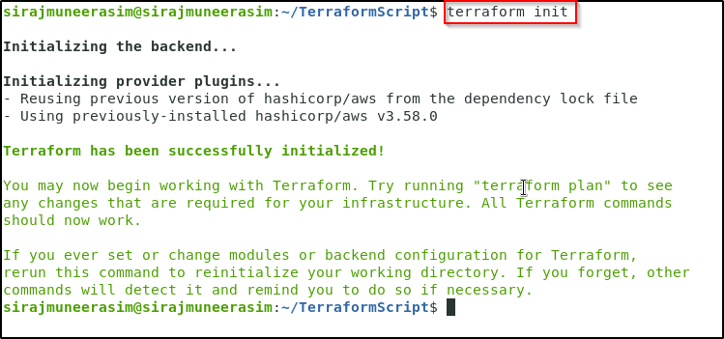

1. Next is the plan stage; it will create the execution graph for creating and provisioning the infrastructure. Run the below command:

***terraform plan***

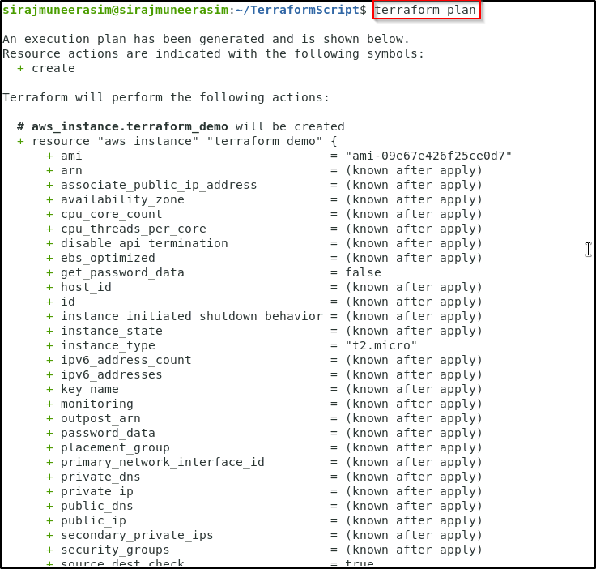

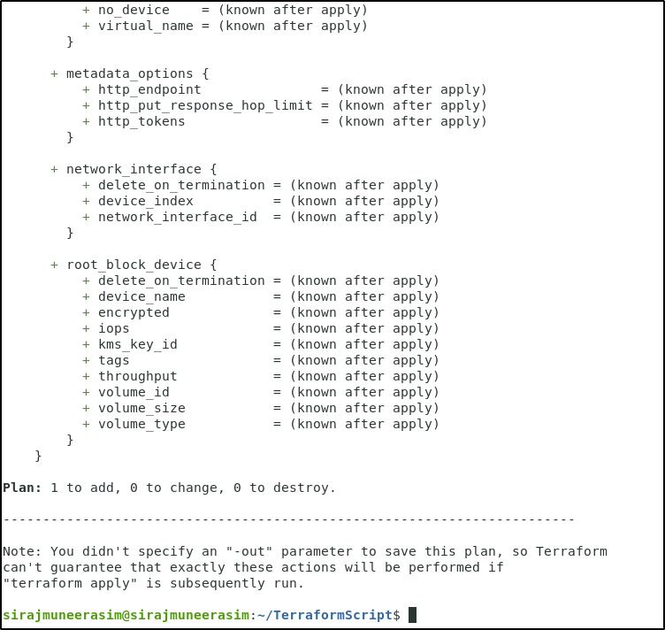

1. The apply stage will execute the configuration file and launch an AWS EC2 instance. Run the below command

***terraform apply***

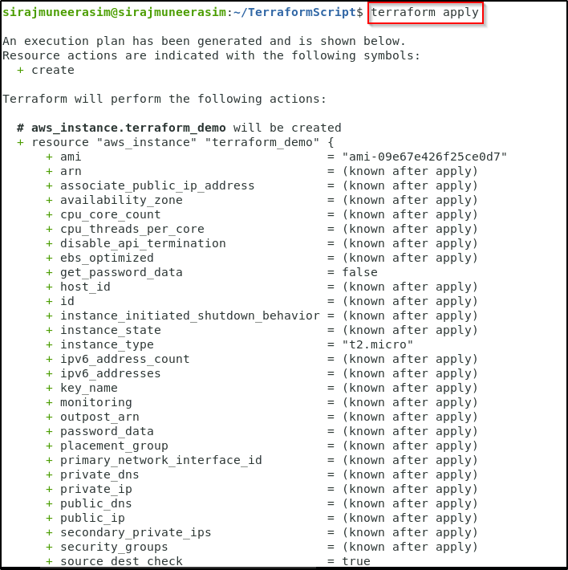

1. When you run the apply command, it will ask, “Do you want to perform these actions?”. You need to type **yes** and hit **enter**.

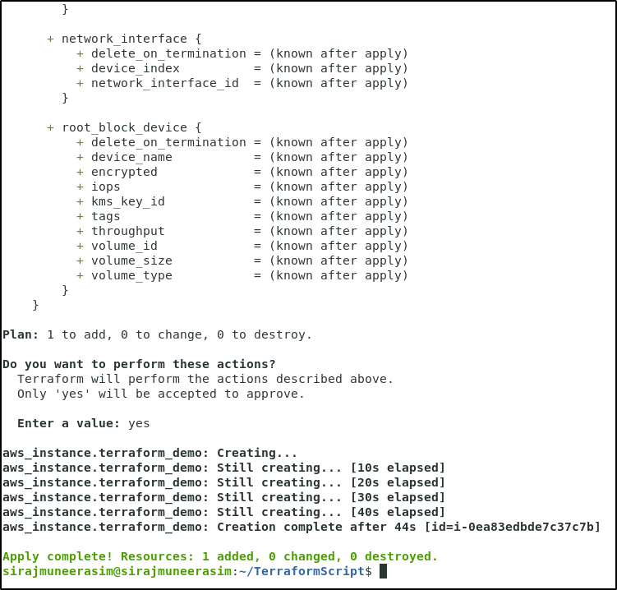

1. Go to your AWS EC2 dashboard, and you will see a new instance with the instance id mentioned at the end of **apply** command that has been created.

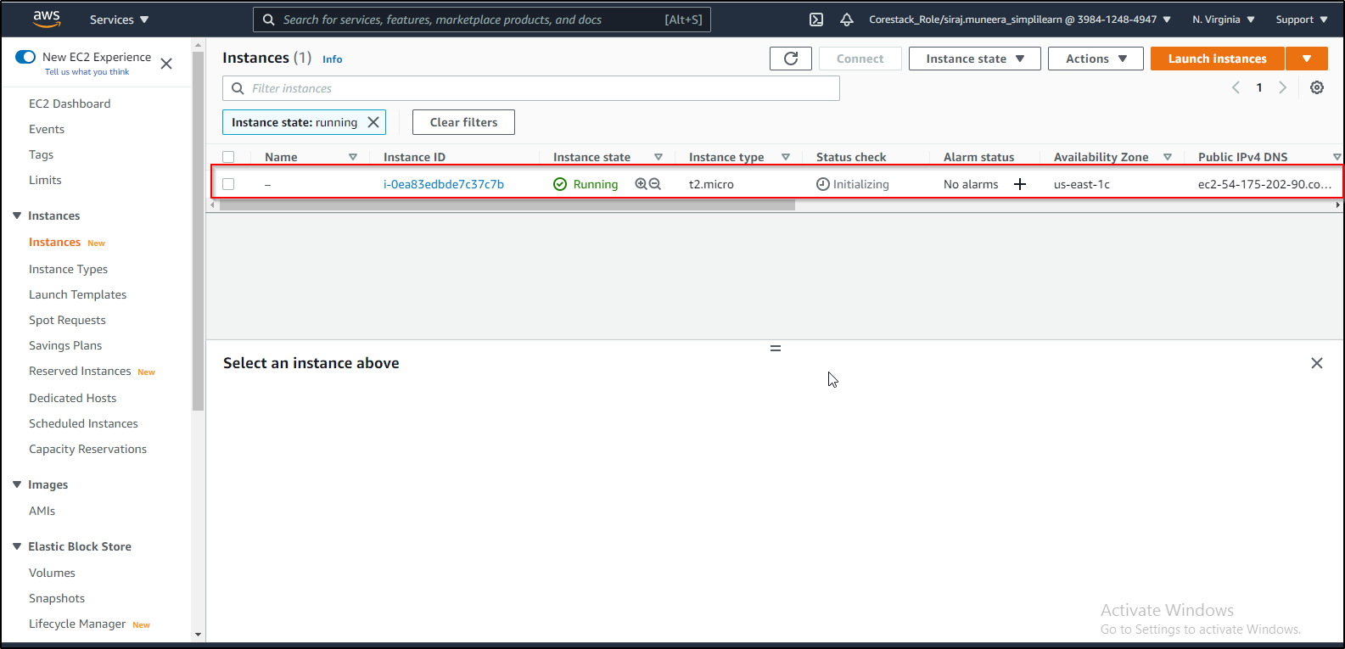

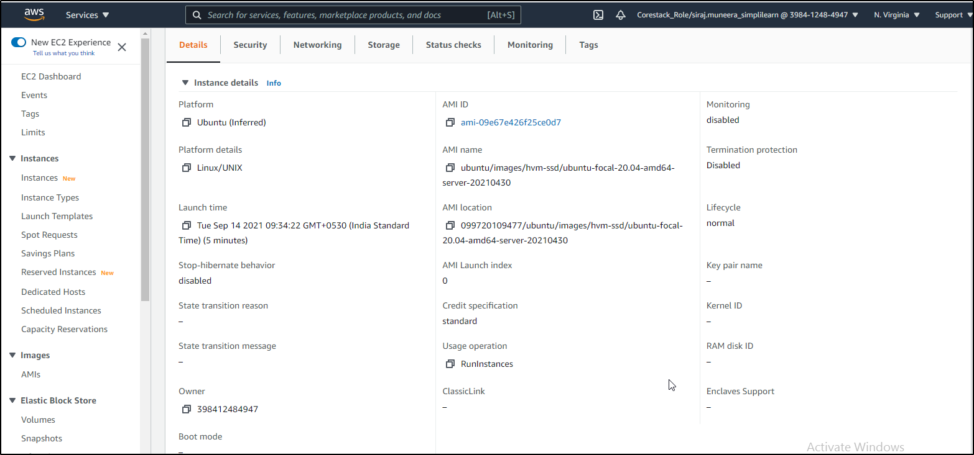

1. You have successfully launched an AWS EC2 instance using Terraform.
2. Finally, if you want to delete the infrastructure, you need to run the destroy command.

***terraform destroy***

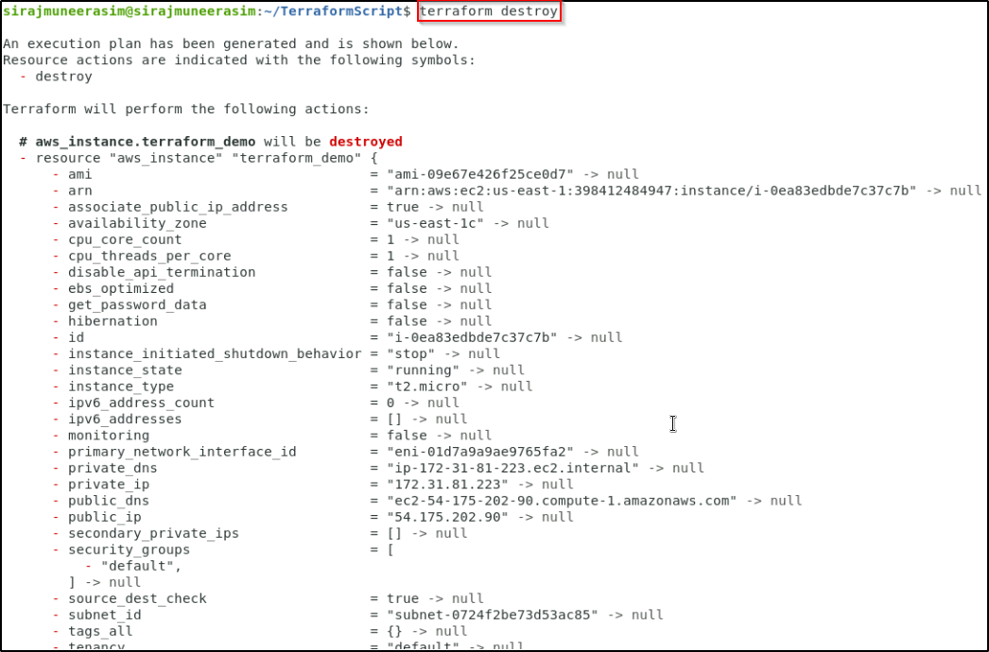

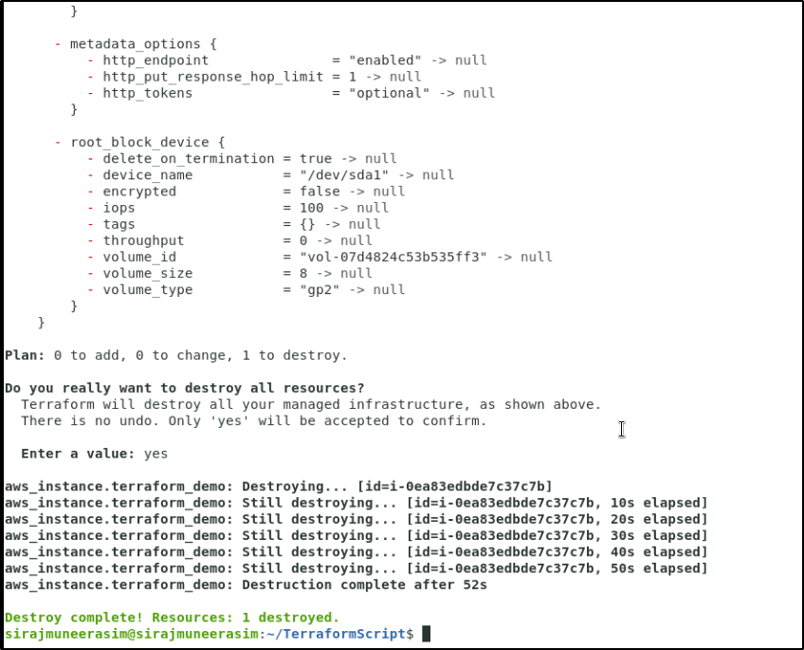

1. If you recheck the EC2 dashboard, you will see that the instance got terminated.